**Wimalawickrama Acharilage Deshan Rasanjana**

**Quantity Surveyor**

I am a strategic thinker with excellent interpersonal communication and presentation skills. Over the years I have proven myself be a reliable person with qualities such as being a fast learner and the ability to actively contribute as a productive team member with the ability to work with different kinds of people and to face challenges.



**Academic Background**

|  |  |
| --- | --- |
| 2020 | **B.Sc. (Hons) in Quantity Surveying**  **(Second Class Upper Division)**  **General Sir John Kotelawala Defence University – Sri Lanka** |
| 2012 | **G.C.E Ordinary Level Examination: Dec 2012 Isipathana College – Colombo 05**  4 A’s, 4 B’s, 1 C’s |
| 2016 | **G.C.E Advance Level Examination: Aug 2016**  **Isipathana College- Colombo 05**  Physics - C, Chemistry- C, Combined Mathematics- C, General English - S |
| **Working Experience** | |
| 2020 Jan to Aug | **Trainee Quantity Surveyor**  Frigi Engineering Services (Pvt) Ltd  Successfully completed internship period as a Quantity Surveyor under supervision NAITA |
|  | |
|  | |
|  | |
|  |  |
|  |
|  |

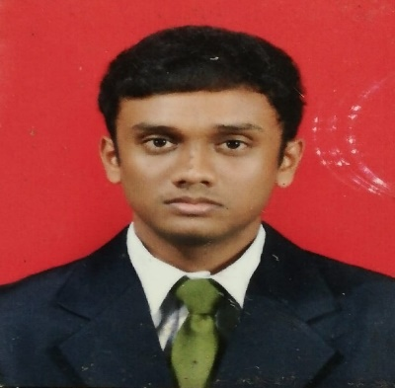

**Personal Info**

**Address**:

194/E2,Thalgahahena Rd, Kesbewa.

**Phone:**

+94766245348

**Email:**

[deshanr99@gmail.com](mailto:deshanr99@gmail.com)

**Date of Birth:**

20/03/1996

**NIC:**

199608001318

**School:**

Isipathana College- Colombo 05

|  |  |  |  |
| --- | --- | --- | --- |
| **Extra-Curricular Activities** | | **Language**  English | |
| * Member of School Science Society 2013-2015. * Member of School Cricket team 2008-2014. * Participated in Inter House Meet below sport activities at the school * Member of school Western Band 2008-2010. | | Sinhala  **Software**  MS Office package    AutoCAD  Cost X | |
| **Referees** | | Primavera | |
| Dr. Sanjaya Jayasooriya  Head of Department  Department of Quantity Surveying  General Sir John Kotelawala Defence University  (+94)7144 14 227 | Wasanatha Wanniarachchi,  *B.Ed, Dip in teach* Justice of the Peace, Sectional Head,  Anula Vidyalaya – Nugegoda.  Mobile: +94 718 123 455  Email: [wasanthaksec@gmail.com](mailto:wasanthaksec@gmail.com) | |
|  |  | |
|  |  |  | |

**I do here by certify that the above given information are true and correct as to the best of my knowledge.**

WAD Rasanjana